Appendix H. Methodology

Appendix H.1. Methodology Flow of the Study with Scrum-Based Prototype Development
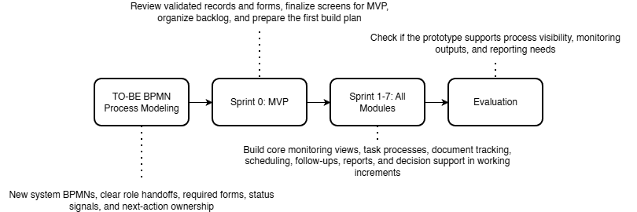

Appendix H.2. Proposed System Development Approach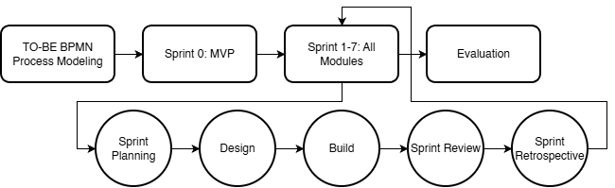

Appendix H.3. Proposed System Development Overview Using Agile Scrum

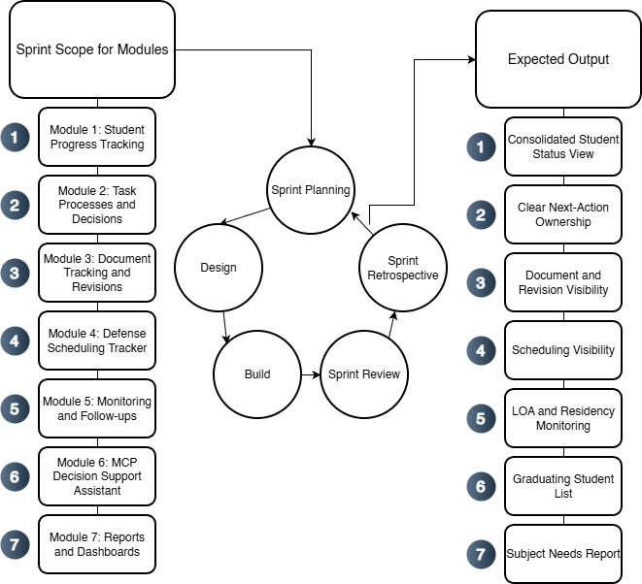

Appendix H.4. Specification Phases for the Proposed Graduate School Monitoring and Decision Support Platform
